CIDRDetail

**Task Description:**

Create a web interface to a Unix bash shell script.

CIDRDetail is a set of Unix bash scripts that takes a CIDR-notation block of IPv4 addresses and runs various checks on it. Once checks are complete, a summarization script can provide a short report. For very large blocks, it may take hours to run, and the summary is no use until it’s complete.

**Skills Required:**

Ubuntu Linux

SSH

Bash shell

PHP or CGI

**Detailed Requirements:**

Currently on tools.retevia.net in /home/ubuntu/NetDetails/ is a bash script called CIDRDetail.sh, and some supporting scripts it calls.

1. Create a web interface so a user can enter a CIDR block (e.g., 192.0.2.0/24) and click “Get detailed report” and it will check whether a report already exists, and if not, execute in the background.
2. Validate that the input is a legitimate IPv4 CIDR block (i.e., four integers 0-255 separated by dots, followed immediately by a slash, followed by an integer 8-32).
3. Save output (e.g., outputfile-192.0.2.0.txt) to a folder where the detail file can be downloaded.
4. Create a web interface (ideally on the same page as the first) where a user can enter a CIDR block and click “Get summary” and if the report already exists, it will run summarize-results.sh on the existing report, and return a web page showing the summary.
5. Add a function to the summary script (summarize-results.sh) checking whether the output file is complete (i.e., whether CIDRDetail.sh is still running on that block); don’t summarize incomplete resutls
6. Add a function to CIDRDetail and summarize-results.sh to query the RADB (including other IRRs) for the block, and record RADB entries were found. (example: whois -h whois.radb.net 83.0.0.0 )

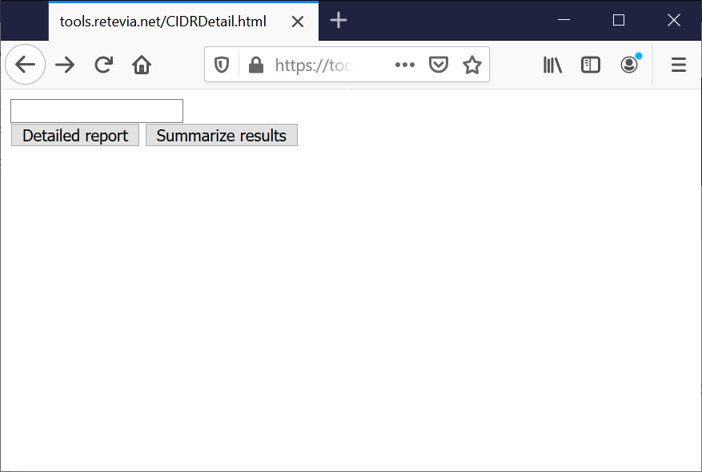

**Quality Assurance:**

Client will perform User Acceptance Testing (UAT). Prior to that, developer should run the tests:

1. Enter several possible CIDR blocks and click “Detailed report””
   1. 192.0.2.0/24 No results
   2. 161.199.161.000/24 Report runs
   3. 83.0.0.0/8 Report runs for a couple of days
2. For seach of several possible inputs, enter the value and run “Summarize results”
   1. 192.0.2.0/24 No results.
   2. 161.199.161.0/24 Summary displays
   3. 83.0.0.0/8 Error displays: “”Detailed report still running”
3. Test for cross-site scripting attacks
4. Download detailed report